|  |  |
| --- | --- |
| **Practicum Case** |  |
| COMP7110  Computer Graphics |
| **Computer Science** | **E1-COMP7110-AI01** |
| ***Valid on*** *Even Semester Year 2019/2020* | **Revision 00** |

## Learning Outcomes

* Define Computer graphics system and architectures
* Explain Graphics with openGL and viewing in graphics programming

## Topic

* Session 04 - GLUT Images

## Sub Topics

* Load Image
* Sprite Slicing

## Soal

*Case*

**GLUT Images**

**GLUT Images** is a simple application created by Software Laboratory Center, Binus University using C++ OpenGL to show how to create a simple Game object with using textures for background and character.

You need to:

* Load and implement texture on quad for background and character

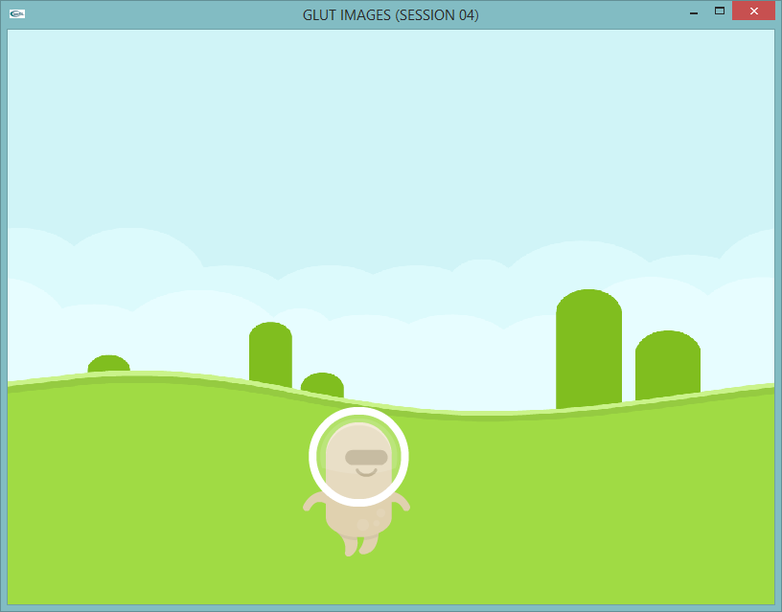

**Figure 1 Main Screen**

* Add player input to sprite the character images:
* ‘**A**’ key to move sprite image backward
* ‘**D**’ key to move sprite image forward
* Validate the move sprite index **cannot be less than 0** and **greater than the number of the sprite images**

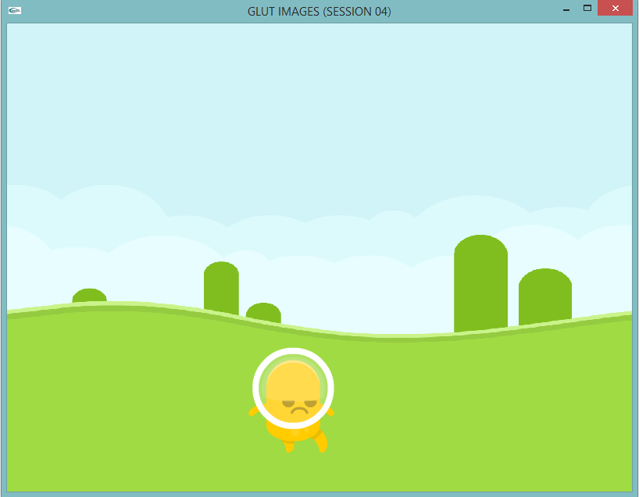

**Figure 2 Sprite Images**

**If anyone does not understand, ask your assistant!**